**CATHOLIC REGIONAL COLLEGE SYDENHAM 2020**

**Software Development – UNIT 3**

**Working Modules – Outcome 301**

**SAC 2021 - Part 2 of 3**

**Name: Noel Tesaluna Date Due:**

Marking Rubric

|  |  |  |  |
| --- | --- | --- | --- |
| **Item #** | **Item Description** | **Marks Available**  (50 marks) | **Marks Awarded** |
| **1** | Create a Windows Forms App that loads the exam file into a list of string arrays. | 5 |  |
| **2** | Implement First and Next navigation buttons and a ShowFields routine | 4 |  |
| **3** | Pass or Fail calculated field | 4 |  |
| **4** | Validation button | 3 |  |
| **5** | Search name function | 9 |  |
| **6** | Test cases | 10 |  |
| **7** |  | 10 |  |
| **8** | Internal Documentation | 5 |  |

**Exam File**

**Student,Subject,Score**

John,Maths,70

Tracy,Maths,65

Henry,Maths,45

William,Maths,70

Barbara,Maths,65

Sally,Maths,49

Peter,Maths,50

**Note** Item 8 requires that you use descriptive and consistent variable naming conventions, procedure headings and appropriate inline comments. 5 marks will be awarded for good internal documentation practices

**Q5 Search Function**

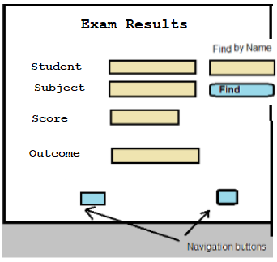

5.1) Create a search function for locating a student by exact match on name (9 marks)

*Pseudo Code:*

**Start LinearSearch()**

**For i = 0 to RowList.RowCount - 1**

**row = RowList[i].Split(comma)**

**studentName = row[NameColumnNumber]**

**If target = studentName Then**

**Return i**

**End If**

**Next i**

**Return -1**

**End**

### Copy a screenshot of your modified form (1 mark)

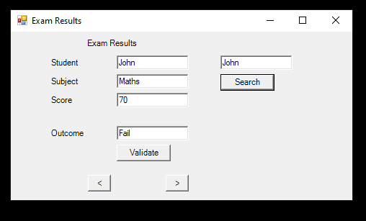

### Copy the code of the Search function (4 marks) and the call of the Search function in the button click event handler (2 marks) here.

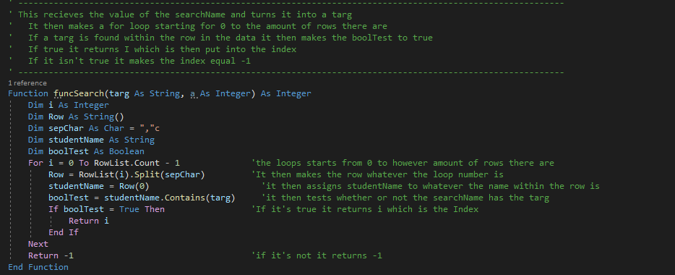

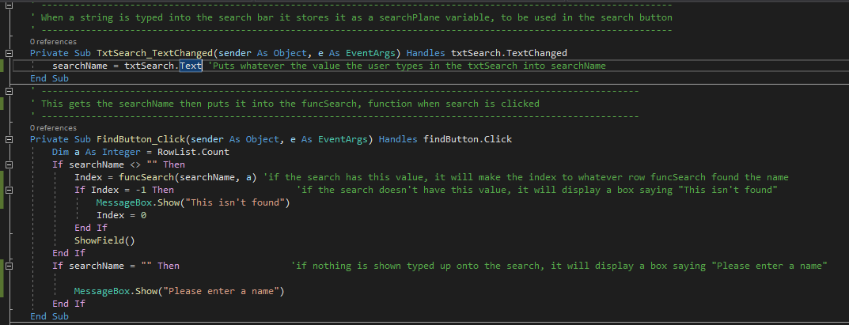

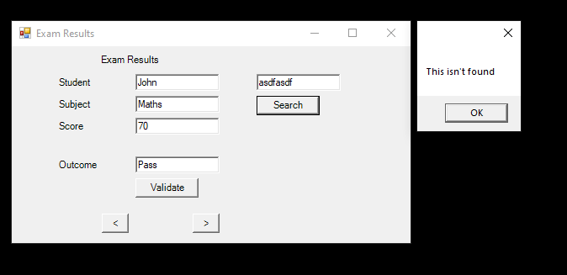

5.2) Modify your search function so that it is not case sensitive. For example searching for ‘john’ will find ‘John’ (2)

Hint: Use the ToUpper or ToLower methods of the String class.

Copy your modified function here

